Міністерство освіти і науки України
Національний університет «Запорізька Політехніка»
Кафедра програмних засобів

ЗВІТ
з лабораторної роботи №4
з дисципліни «Системний аналіз» на тему:
«Створення програмних систем»

Виконав
Студент групи КНТ-122 О. А. Онищенко

Прийняли
Викладач Л. Ю. Дейнега

2024

Створення програмних систем

Мета роботи

Ознайомитися з принципами компонетно-орієнтованого програмування; навчитися застосовувати системний підхід для побудови програмного забезпечення

Завдання

- Розробити програмне забезпечення продажу квитків на літак. Адміністратор визначає маршрути, дати перельотів, наявні місця. Користувачі мають можливість купувати квитки. При цьому можна або обрати конкретне місце в літаку, або за день до вильоту система автоматично має розподілити місця між всіма пасажирами, що не обрали місце. Спочатку виконується бронювання квитка, дійсне протягом доби. Якщо гроші за квиток внесло, то він вважається придбаним. Факт сплати за квиток можна моделювати випадковим чином. Адміністратору доступна статистика щодо продажів. Без реєстрації користувач не може купити квиток
- Розробити програмне забезпечення у відповідності з індивідуальним завданням. Усі функції системи повинні бути реалізовані у вигляді необхідної кількості програмних компонентів .NET мовою C#, для чого потрібно ще до реалізації забезпечити відповідний процес проєктування з обгрунтуванням отриманих результатів. Клієнтське застосування повинно використовувати функції з компонентів через програмні інтерфейси. Програмне забезпечення обов'язково має відповідати вимогам безпеки даних та програмного коду. Необхідні програмні компоненти спроєктувати на основі застосування системного підходу

Код програми

// currentUser.cs
using System;
using System.Collections.Generic;
using System.Linq;
using System.Text;
using System.Threading.Tasks;

namespace dev
{
public static class currentUser
{
public static string name { get; set; }
public static string password { get; set; }
public static bool isAdmin { get; set; }
}
}

// flight.cs
using System;
using System.Collections.Generic;
using System.Linq;
using System.Text;
using System.Threading.Tasks;

namespace dev
{
public class flight
{
public string name { get; set; }
public int price { get; set; }
public string date { get; set; }
public int seats { get; set; }
}
}

// flights.cs
using System;
using System.Collections.Generic;
using System.ComponentModel;
using System.Data;
using System.Drawing;
using System.Linq;
using System.Text;
using System.Threading.Tasks;
using System.Windows.Forms;

namespace dev
{
public partial class flights : Form
{
public flight selectedFlight;
public const int collapsedHeight = 190;
public const int expandedHeight = 560;

public int totalPrice;
public int seatTypePrice = 0;
public int mealPrice = 0;
public int luggagePrice = 0;
public int privatePrice = 0;

public flights()
{
InitializeComponent();
infoPanel.Visible = false;
optionsPanel.Visible = false;
this.Height = collapsedHeight;

List<flight> flights = flightsDataManager.loadFlights();
renderFlightNames(flights);
}

public void updateTotal()
{
totalPrice = selectedFlight.price + seatTypePrice + mealPrice + luggagePrice + privatePrice;
totalPriceLabel.Text = $"In total: ${totalPrice}";
}

public void renderFlightNames(List<flight> flights)
{
flightsList.Items.Clear();
foreach (flight flight in flights)
{
flightsList.Items.Add(flight.name);
}
}

private void menuButton_Click(object sender, EventArgs e)
{
this.Hide();
menu menu = new menu();
menu.Show();
}

private void flightsList_SelectedValueChanged(object sender, EventArgs e)
{
selectedFlight = flightsDataManager.getFlight(flightsList.SelectedItem.ToString());
infoPanel.Visible = true;
optionsPanel.Visible = true;
this.Height = expandedHeight;

selectedLabel.Text = selectedFlight.name;
priceLabel.Text = $"Ticket price: ${selectedFlight.price}";
dateLabel.Text = $"Flight date: {selectedFlight.date.Replace("-", "/")}";
seatsLabel.Text = $"Available seats: {selectedFlight.seats}";

int seatRows = (int)Math.Floor((double)selectedFlight.seats / 10);
rowSelect.Maximum = seatRows;

totalPrice = selectedFlight.price;
updateTotal();
}

private void middleRadio_CheckedChanged(object sender, EventArgs e)
{
if (middleRadio.Checked)
{
randomRadio.Checked = false;
windowRadio.Checked = false;
seatTypePrice = 10;
updateTotal();
}
}

private void randomRadio_CheckedChanged(object sender, EventArgs e)
{
if (randomRadio.Checked)
{
windowRadio.Checked = false;
middleRadio.Checked = false;
seatTypePrice = 0;
updateTotal();
}
}

private void windowRadio_CheckedChanged(object sender, EventArgs e)
{
if (windowRadio.Checked)
{
randomRadio.Checked = false;
middleRadio.Checked = false;
seatTypePrice = 30;
updateTotal();
}
}

private void mealBox_CheckedChanged(object sender, EventArgs e)
{
mealPrice = mealBox.Checked ? 15 : 0;
updateTotal();
}

private void luggageBox_CheckedChanged(object sender, EventArgs e)
{
luggagePrice = luggageBox.Checked ? 30 : 0;
updateTotal();
}

private void privateBox_CheckedChanged(object sender, EventArgs e)
{
privatePrice = privateBox.Checked ? 77 : 0;
updateTotal();
}

private void bookButton_Click(object sender, EventArgs e)
{
ticketsDataManager.AddTicket(currentUser.name, selectedFlight.name, totalPrice, selectedFlight.date, (int)rowSelect.Value, middleRadio.Checked, windowRadio.Checked, privateBox.Checked, luggageBox.Checked, mealBox.Checked);
MessageBox.Show("Ticket booked successfully");
this.Hide();
menu menu = new menu();
menu.Show();
}
}
}

// flights.Designer.cs
namespace dev
{
partial class flights
{
/// <summary>
/// Required designer variable.
/// </summary>
private System.ComponentModel.IContainer components = null;

/// <summary>
/// Clean up any resources being used.
/// </summary>
/// <param name="disposing">true if managed resources should be disposed; otherwise, false.</param>
protected override void Dispose(bool disposing)
{
if (disposing && (components != null))
{
components.Dispose();
}
base.Dispose(disposing);
}

#region Windows Form Designer generated code

/// <summary>
/// Required method for Designer support - do not modify
/// the contents of this method with the code editor.
/// </summary>
private void InitializeComponent()
{
this.menuButton = new System.Windows.Forms.Button();
this.selectedLabel = new System.Windows.Forms.Label();
this.flightsList = new System.Windows.Forms.ListBox();
this.priceLabel = new System.Windows.Forms.Label();
this.dateLabel = new System.Windows.Forms.Label();
this.seatsLabel = new System.Windows.Forms.Label();
this.seatHeading = new System.Windows.Forms.Label();
this.infoPanel = new System.Windows.Forms.Panel();
this.optionsPanel = new System.Windows.Forms.Panel();
this.windowRadio = new System.Windows.Forms.RadioButton();
this.bookButton = new System.Windows.Forms.Button();
this.totalPriceLabel = new System.Windows.Forms.Label();
this.extrasLabel = new System.Windows.Forms.Label();
this.privateBox = new System.Windows.Forms.CheckBox();
this.luggageBox = new System.Windows.Forms.CheckBox();
this.mealBox = new System.Windows.Forms.CheckBox();
this.middleRadio = new System.Windows.Forms.RadioButton();
this.randomRadio = new System.Windows.Forms.RadioButton();
this.seatTypeLabel = new System.Windows.Forms.Label();
this.rowSelect = new System.Windows.Forms.NumericUpDown();
this.rowsLabel = new System.Windows.Forms.Label();
this.infoPanel.SuspendLayout();
this.optionsPanel.SuspendLayout();
((System.ComponentModel.ISupportInitialize)(this.rowSelect)).BeginInit();
this.SuspendLayout();
//
// menuButton
//
this.menuButton.Location = new System.Drawing.Point(12, 12);
this.menuButton.Name = "menuButton";
this.menuButton.Size = new System.Drawing.Size(104, 34);
this.menuButton.TabIndex = 0;
this.menuButton.Text = "back";
this.menuButton.UseVisualStyleBackColor = true;
this.menuButton.Click += new System.EventHandler(this.menuButton_Click);
//
// selectedLabel
//
this.selectedLabel.AutoSize = true;
this.selectedLabel.Font = new System.Drawing.Font("Microsoft Sans Serif", 12F, System.Drawing.FontStyle.Bold, System.Drawing.GraphicsUnit.Point, ((byte)(0)));
this.selectedLabel.Location = new System.Drawing.Point(3, 0);
this.selectedLabel.Name = "selectedLabel";
this.selectedLabel.Size = new System.Drawing.Size(333, 29);
this.selectedLabel.TabIndex = 2;
this.selectedLabel.Text = "Selected flight name here...";
//
// flightsList
//
this.flightsList.FormattingEnabled = true;
this.flightsList.ItemHeight = 20;
this.flightsList.Items.AddRange(new object[] {
"flight names here..."});
this.flightsList.Location = new System.Drawing.Point(12, 66);
this.flightsList.Name = "flightsList";
this.flightsList.Size = new System.Drawing.Size(629, 144);
this.flightsList.TabIndex = 3;
this.flightsList.SelectedValueChanged += new System.EventHandler(this.flightsList_SelectedValueChanged);
//
// priceLabel
//
this.priceLabel.AutoSize = true;
this.priceLabel.Location = new System.Drawing.Point(4, 39);
this.priceLabel.Name = "priceLabel";
this.priceLabel.Size = new System.Drawing.Size(137, 20);
this.priceLabel.TabIndex = 4;
this.priceLabel.Text = "Ticket price here...";
//
// dateLabel
//
this.dateLabel.AutoSize = true;
this.dateLabel.Location = new System.Drawing.Point(4, 68);
this.dateLabel.Name = "dateLabel";
this.dateLabel.Size = new System.Drawing.Size(135, 20);
this.dateLabel.TabIndex = 5;
this.dateLabel.Text = "Ticket date here...";
//
// seatsLabel
//
this.seatsLabel.AutoSize = true;
this.seatsLabel.Location = new System.Drawing.Point(4, 98);
this.seatsLabel.Name = "seatsLabel";
this.seatsLabel.Size = new System.Drawing.Size(142, 20);
this.seatsLabel.TabIndex = 6;
this.seatsLabel.Text = "Ticket seats here...";
//
// seatHeading
//
this.seatHeading.AutoSize = true;
this.seatHeading.Font = new System.Drawing.Font("Microsoft Sans Serif", 10F, System.Drawing.FontStyle.Bold, System.Drawing.GraphicsUnit.Point, ((byte)(0)));
this.seatHeading.Location = new System.Drawing.Point(3, 0);
this.seatHeading.Name = "seatHeading";
this.seatHeading.Size = new System.Drawing.Size(120, 25);
this.seatHeading.TabIndex = 7;
this.seatHeading.Text = "Select seat";
//
// infoPanel
//
this.infoPanel.Controls.Add(this.selectedLabel);
this.infoPanel.Controls.Add(this.priceLabel);
this.infoPanel.Controls.Add(this.seatsLabel);
this.infoPanel.Controls.Add(this.dateLabel);
this.infoPanel.Location = new System.Drawing.Point(12, 229);
this.infoPanel.Name = "infoPanel";
this.infoPanel.Size = new System.Drawing.Size(629, 131);
this.infoPanel.TabIndex = 8;
//
// optionsPanel
//
this.optionsPanel.Controls.Add(this.windowRadio);
this.optionsPanel.Controls.Add(this.bookButton);
this.optionsPanel.Controls.Add(this.totalPriceLabel);
this.optionsPanel.Controls.Add(this.extrasLabel);
this.optionsPanel.Controls.Add(this.privateBox);
this.optionsPanel.Controls.Add(this.luggageBox);
this.optionsPanel.Controls.Add(this.mealBox);
this.optionsPanel.Controls.Add(this.middleRadio);
this.optionsPanel.Controls.Add(this.randomRadio);
this.optionsPanel.Controls.Add(this.seatTypeLabel);
this.optionsPanel.Controls.Add(this.rowSelect);
this.optionsPanel.Controls.Add(this.rowsLabel);
this.optionsPanel.Controls.Add(this.seatHeading);
this.optionsPanel.Location = new System.Drawing.Point(12, 366);
this.optionsPanel.Name = "optionsPanel";
this.optionsPanel.Size = new System.Drawing.Size(629, 428);
this.optionsPanel.TabIndex = 9;
//
// windowRadio
//
this.windowRadio.AutoSize = true;
this.windowRadio.Location = new System.Drawing.Point(8, 182);
this.windowRadio.Name = "windowRadio";
this.windowRadio.Size = new System.Drawing.Size(174, 24);
this.windowRadio.TabIndex = 19;
this.windowRadio.Text = "Window seat | +$30";
this.windowRadio.UseVisualStyleBackColor = true;
this.windowRadio.CheckedChanged += new System.EventHandler(this.windowRadio_CheckedChanged);
//
// bookButton
//
this.bookButton.Location = new System.Drawing.Point(8, 377);
this.bookButton.Name = "bookButton";
this.bookButton.Size = new System.Drawing.Size(618, 45);
this.bookButton.TabIndex = 18;
this.bookButton.Text = "Book Ticket";
this.bookButton.UseVisualStyleBackColor = true;
this.bookButton.Click += new System.EventHandler(this.bookButton_Click);
//
// totalPriceLabel
//
this.totalPriceLabel.AutoSize = true;
this.totalPriceLabel.Font = new System.Drawing.Font("Microsoft Sans Serif", 8F, System.Drawing.FontStyle.Bold, System.Drawing.GraphicsUnit.Point, ((byte)(0)));
this.totalPriceLabel.Location = new System.Drawing.Point(4, 345);
this.totalPriceLabel.Name = "totalPriceLabel";
this.totalPriceLabel.Size = new System.Drawing.Size(86, 20);
this.totalPriceLabel.TabIndex = 17;
this.totalPriceLabel.Text = "In total: $";
//
// extrasLabel
//
this.extrasLabel.AutoSize = true;
this.extrasLabel.Location = new System.Drawing.Point(4, 222);
this.extrasLabel.Name = "extrasLabel";
this.extrasLabel.Size = new System.Drawing.Size(214, 20);
this.extrasLabel.TabIndex = 16;
this.extrasLabel.Text = "Select optional extra services";
//
// privateBox
//
this.privateBox.AutoSize = true;
this.privateBox.Location = new System.Drawing.Point(8, 305);
this.privateBox.Name = "privateBox";
this.privateBox.Size = new System.Drawing.Size(230, 24);
this.privateBox.TabIndex = 15;
this.privateBox.Text = "Private compartment | +$77";
this.privateBox.UseVisualStyleBackColor = true;
this.privateBox.CheckedChanged += new System.EventHandler(this.privateBox_CheckedChanged);
//
// luggageBox
//
this.luggageBox.AutoSize = true;
this.luggageBox.Location = new System.Drawing.Point(8, 275);
this.luggageBox.Name = "luggageBox";
this.luggageBox.Size = new System.Drawing.Size(229, 24);
this.luggageBox.TabIndex = 14;
this.luggageBox.Text = "Extra luggage space | +$30";
this.luggageBox.UseVisualStyleBackColor = true;
this.luggageBox.CheckedChanged += new System.EventHandler(this.luggageBox_CheckedChanged);
//
// mealBox
//
this.mealBox.AutoSize = true;
this.mealBox.Location = new System.Drawing.Point(8, 245);
this.mealBox.Name = "mealBox";
this.mealBox.Size = new System.Drawing.Size(185, 24);
this.mealBox.TabIndex = 13;
this.mealBox.Text = "Meal on board | +$15";
this.mealBox.UseVisualStyleBackColor = true;
this.mealBox.CheckedChanged += new System.EventHandler(this.mealBox_CheckedChanged);
//
// middleRadio
//
this.middleRadio.AutoSize = true;
this.middleRadio.Location = new System.Drawing.Point(8, 152);
this.middleRadio.Name = "middleRadio";
this.middleRadio.Size = new System.Drawing.Size(158, 24);
this.middleRadio.TabIndex = 12;
this.middleRadio.Text = "Middle row | +$10";
this.middleRadio.UseVisualStyleBackColor = true;
this.middleRadio.CheckedChanged += new System.EventHandler(this.middleRadio_CheckedChanged);
//
// randomRadio
//
this.randomRadio.AutoSize = true;
this.randomRadio.Checked = true;
this.randomRadio.Location = new System.Drawing.Point(8, 122);
this.randomRadio.Name = "randomRadio";
this.randomRadio.Size = new System.Drawing.Size(170, 24);
this.randomRadio.TabIndex = 11;
this.randomRadio.TabStop = true;
this.randomRadio.Text = "Random seat | +$0";
this.randomRadio.UseVisualStyleBackColor = true;
this.randomRadio.CheckedChanged += new System.EventHandler(this.randomRadio_CheckedChanged);
//
// seatTypeLabel
//
this.seatTypeLabel.AutoSize = true;
this.seatTypeLabel.Location = new System.Drawing.Point(4, 99);
this.seatTypeLabel.Name = "seatTypeLabel";
this.seatTypeLabel.Size = new System.Drawing.Size(123, 20);
this.seatTypeLabel.TabIndex = 10;
this.seatTypeLabel.Text = "Select seat type";
//
// rowSelect
//
this.rowSelect.Location = new System.Drawing.Point(8, 59);
this.rowSelect.Minimum = new decimal(new int[] {
1,
0,
0,
0});
this.rowSelect.Name = "rowSelect";
this.rowSelect.Size = new System.Drawing.Size(618, 26);
this.rowSelect.TabIndex = 9;
this.rowSelect.Value = new decimal(new int[] {
1,
0,
0,
0});
//
// rowsLabel
//
this.rowsLabel.AutoSize = true;
this.rowsLabel.Location = new System.Drawing.Point(4, 36);
this.rowsLabel.Name = "rowsLabel";
this.rowsLabel.Size = new System.Drawing.Size(118, 20);
this.rowsLabel.TabIndex = 8;
this.rowsLabel.Text = "Select seat row";
//
// flights
//
this.AutoScaleDimensions = new System.Drawing.SizeF(9F, 20F);
this.AutoScaleMode = System.Windows.Forms.AutoScaleMode.Font;
this.ClientSize = new System.Drawing.Size(653, 804);
this.Controls.Add(this.optionsPanel);
this.Controls.Add(this.infoPanel);
this.Controls.Add(this.flightsList);
this.Controls.Add(this.menuButton);
this.Name = "flights";
this.Text = "flights";
this.infoPanel.ResumeLayout(false);
this.infoPanel.PerformLayout();
this.optionsPanel.ResumeLayout(false);
this.optionsPanel.PerformLayout();
((System.ComponentModel.ISupportInitialize)(this.rowSelect)).EndInit();
this.ResumeLayout(false);

}

#endregion

private System.Windows.Forms.Button menuButton;
private System.Windows.Forms.Label selectedLabel;
private System.Windows.Forms.ListBox flightsList;
private System.Windows.Forms.Label priceLabel;
private System.Windows.Forms.Label dateLabel;
private System.Windows.Forms.Label seatsLabel;
private System.Windows.Forms.Label seatHeading;
private System.Windows.Forms.Panel infoPanel;
private System.Windows.Forms.Panel optionsPanel;
private System.Windows.Forms.NumericUpDown rowSelect;
private System.Windows.Forms.Label rowsLabel;
private System.Windows.Forms.RadioButton middleRadio;
private System.Windows.Forms.RadioButton randomRadio;
private System.Windows.Forms.Label seatTypeLabel;
private System.Windows.Forms.CheckBox luggageBox;
private System.Windows.Forms.CheckBox mealBox;
private System.Windows.Forms.Label extrasLabel;
private System.Windows.Forms.CheckBox privateBox;
private System.Windows.Forms.Button bookButton;
private System.Windows.Forms.Label totalPriceLabel;
private System.Windows.Forms.RadioButton windowRadio;
}
}

# flights.txt
Zaporizhzhia Airport - Choctaw Airport,50,11-05-2024,77
Zaporizhzhia Airport - Sandpoint Airport,40,12-05-2024,77
Zaporizhzhia Airport - Kootenai Airport,30,13-05-2024,77
Kyiv Airport - Chernihiv Airport,60,14-05-2024,77
Poltava Airport - Kryvyi Rih Airport,77,15-05-2024,77
Zhytomyr Airport - Chernivtsi Airport,70,16-05-2024,77
Lviv Airport - Kharkiv Airport,67,17-05-2024,77

// flightsDataManager.cs
using System;
using System.Collections.Generic;
using System.IO;
using System.Linq;
using System.Text;
using System.Threading.Tasks;

namespace dev
{
public class flightsDataManager
{
public static string flightsFilePath = "E:\\all\\University\\y2t2\\SA\\tasks\\lb4\\dev\\flights.txt";

public static List<flight> loadFlights()
{
List<flight> flights = new List<flight>();
if (File.Exists(flightsFilePath))
{
string[] strings = File.ReadAllLines(flightsFilePath);
foreach (string line in strings)
{
string[] parts = line.Split(',');
if (parts.Length == 4)
{
flight flight = new flight
{
name = parts[0],
price = int.Parse(parts[1]),
date = parts[2],
seats = int.Parse(parts[3])
};
flights.Add(flight);
}
}
}
return flights;
}

public static flight getFlight(string name)
{
List<flight> flights = loadFlights();
foreach (flight flight in flights)
{
if (flight.name == name)
{
return flight;
}
}
return null;
}
}
}

// login.cs
using System;
using System.Collections.Generic;
using System.ComponentModel;
using System.Data;
using System.Drawing;
using System.Linq;
using System.Text;
using System.Threading.Tasks;
using System.Windows.Forms;

namespace dev
{
public partial class login : Form
{
public login()
{
InitializeComponent();
}

public void loginButton_Click(object sender, EventArgs e)
{
string name = nameInput.Text;
string password = passwordInput.Text;

if (name == "" || password == "")
{
MessageBox.Show("Please enter username and password");
nameInput.Text = "";
passwordInput.Text = "";
return;
}

if (userDataManager.validateCredentials(name, password))
{
currentUser.name = name;
currentUser.password = password;
currentUser.isAdmin = userDataManager.isAdmin(name);

this.Hide();
menu menu = new menu();
menu.Show();
}
else
{
MessageBox.Show("Invalid username or password");
nameInput.Text = "";
passwordInput.Text = "";
}
}

private void registerButton_Click(object sender, EventArgs e)
{
this.Hide();
signup signup = new signup();
signup.Show();
}
}
}

// login.Designer.cs
namespace dev
{
partial class login
{
/// <summary>
/// Required designer variable.
/// </summary>
private System.ComponentModel.IContainer components = null;

/// <summary>
/// Clean up any resources being used.
/// </summary>
/// <param name="disposing">true if managed resources should be disposed; otherwise, false.</param>
protected override void Dispose(bool disposing)
{
if (disposing && (components != null))
{
components.Dispose();
}
base.Dispose(disposing);
}

#region Windows Form Designer generated code

/// <summary>
/// Required method for Designer support - do not modify
/// the contents of this method with the code editor.
/// </summary>
private void InitializeComponent()
{
this.nameInput = new System.Windows.Forms.TextBox();
this.passwordInput = new System.Windows.Forms.TextBox();
this.nameLabel = new System.Windows.Forms.Label();
this.passwordLabel = new System.Windows.Forms.Label();
this.loginButton = new System.Windows.Forms.Button();
this.registerButton = new System.Windows.Forms.Button();
this.SuspendLayout();
//
// nameInput
//
this.nameInput.Location = new System.Drawing.Point(16, 32);
this.nameInput.Name = "nameInput";
this.nameInput.Size = new System.Drawing.Size(352, 26);
this.nameInput.TabIndex = 0;
//
// passwordInput
//
this.passwordInput.Location = new System.Drawing.Point(16, 96);
this.passwordInput.Name = "passwordInput";
this.passwordInput.Size = new System.Drawing.Size(352, 26);
this.passwordInput.TabIndex = 1;
//
// nameLabel
//
this.nameLabel.AutoSize = true;
this.nameLabel.Location = new System.Drawing.Point(12, 9);
this.nameLabel.Name = "nameLabel";
this.nameLabel.Size = new System.Drawing.Size(49, 20);
this.nameLabel.TabIndex = 2;
this.nameLabel.Text = "name";
//
// passwordLabel
//
this.passwordLabel.AutoSize = true;
this.passwordLabel.Location = new System.Drawing.Point(12, 73);
this.passwordLabel.Name = "passwordLabel";
this.passwordLabel.Size = new System.Drawing.Size(77, 20);
this.passwordLabel.TabIndex = 3;
this.passwordLabel.Text = "password";
//
// loginButton
//
this.loginButton.Location = new System.Drawing.Point(16, 139);
this.loginButton.Name = "loginButton";
this.loginButton.Size = new System.Drawing.Size(352, 41);
this.loginButton.TabIndex = 4;
this.loginButton.Text = "login";
this.loginButton.UseVisualStyleBackColor = true;
this.loginButton.Click += new System.EventHandler(this.loginButton_Click);
//
// registerButton
//
this.registerButton.Location = new System.Drawing.Point(16, 186);
this.registerButton.Name = "registerButton";
this.registerButton.Size = new System.Drawing.Size(352, 44);
this.registerButton.TabIndex = 5;
this.registerButton.Text = "register";
this.registerButton.UseVisualStyleBackColor = true;
this.registerButton.Click += new System.EventHandler(this.registerButton_Click);
//
// login
//
this.AutoScaleDimensions = new System.Drawing.SizeF(9F, 20F);
this.AutoScaleMode = System.Windows.Forms.AutoScaleMode.Font;
this.ClientSize = new System.Drawing.Size(386, 251);
this.Controls.Add(this.registerButton);
this.Controls.Add(this.loginButton);
this.Controls.Add(this.passwordLabel);
this.Controls.Add(this.nameLabel);
this.Controls.Add(this.passwordInput);
this.Controls.Add(this.nameInput);
this.Name = "login";
this.Text = "login";
this.ResumeLayout(false);
this.PerformLayout();

}

#endregion

private System.Windows.Forms.TextBox nameInput;
private System.Windows.Forms.TextBox passwordInput;
private System.Windows.Forms.Label nameLabel;
private System.Windows.Forms.Label passwordLabel;
private System.Windows.Forms.Button loginButton;
private System.Windows.Forms.Button registerButton;
}
}

// menu.cs
using System;
using System.Collections.Generic;
using System.ComponentModel;
using System.Data;
using System.Drawing;
using System.Linq;
using System.Text;
using System.Threading.Tasks;
using System.Windows.Forms;

namespace dev
{
public partial class menu : Form
{
public menu()
{
InitializeComponent();

if (currentUser.isAdmin)
{
ticketsButton.Text = "All Tickets";
}
}

private void signoutButton_Click(object sender, EventArgs e)
{
this.Hide();
login login = new login();
login.Show();
}

private void flightsButton_Click(object sender, EventArgs e)
{
this.Hide();
flights flights = new flights();
flights.Show();
}

private void ticketsButton_Click(object sender, EventArgs e)
{
this.Hide();
tickets tickets = new tickets();
tickets.Show();
}
}
}

// menu.Designer.cs
namespace dev
{
partial class menu
{
/// <summary>
/// Required designer variable.
/// </summary>
private System.ComponentModel.IContainer components = null;

/// <summary>
/// Clean up any resources being used.
/// </summary>
/// <param name="disposing">true if managed resources should be disposed; otherwise, false.</param>
protected override void Dispose(bool disposing)
{
if (disposing && (components != null))
{
components.Dispose();
}
base.Dispose(disposing);
}

#region Windows Form Designer generated code

/// <summary>
/// Required method for Designer support - do not modify
/// the contents of this method with the code editor.
/// </summary>
private void InitializeComponent()
{
this.signoutButton = new System.Windows.Forms.Button();
this.flightsButton = new System.Windows.Forms.Button();
this.ticketsButton = new System.Windows.Forms.Button();
this.SuspendLayout();
//
// signoutButton
//
this.signoutButton.Location = new System.Drawing.Point(12, 128);
this.signoutButton.Name = "signoutButton";
this.signoutButton.Size = new System.Drawing.Size(370, 49);
this.signoutButton.TabIndex = 0;
this.signoutButton.Text = "Sign Out";
this.signoutButton.UseVisualStyleBackColor = true;
this.signoutButton.Click += new System.EventHandler(this.signoutButton_Click);
//
// flightsButton
//
this.flightsButton.Location = new System.Drawing.Point(12, 12);
this.flightsButton.Name = "flightsButton";
this.flightsButton.Size = new System.Drawing.Size(370, 53);
this.flightsButton.TabIndex = 1;
this.flightsButton.Text = "Available Flights";
this.flightsButton.UseVisualStyleBackColor = true;
this.flightsButton.Click += new System.EventHandler(this.flightsButton_Click);
//
// ticketsButton
//
this.ticketsButton.Location = new System.Drawing.Point(12, 71);
this.ticketsButton.Name = "ticketsButton";
this.ticketsButton.Size = new System.Drawing.Size(370, 51);
this.ticketsButton.TabIndex = 2;
this.ticketsButton.Text = "Tickets";
this.ticketsButton.UseVisualStyleBackColor = true;
this.ticketsButton.Click += new System.EventHandler(this.ticketsButton_Click);
//
// menu
//
this.AutoScaleDimensions = new System.Drawing.SizeF(9F, 20F);
this.AutoScaleMode = System.Windows.Forms.AutoScaleMode.Font;
this.ClientSize = new System.Drawing.Size(394, 193);
this.Controls.Add(this.ticketsButton);
this.Controls.Add(this.flightsButton);
this.Controls.Add(this.signoutButton);
this.Name = "menu";
this.Text = "menu";
this.ResumeLayout(false);

}

#endregion

private System.Windows.Forms.Button signoutButton;
private System.Windows.Forms.Button flightsButton;
private System.Windows.Forms.Button ticketsButton;
}
}

// Program.cs
using System;
using System.Collections.Generic;
using System.Linq;
using System.Threading.Tasks;
using System.Windows.Forms;

namespace dev
{
internal static class Program
{
/// <summary>
/// The main entry point for the application.
/// </summary>
[STAThread]
static void Main()
{
Application.EnableVisualStyles();
Application.SetCompatibleTextRenderingDefault(false);
Application.Run(new login());
}
}
}

// signup.cs
using System;
using System.Collections.Generic;
using System.ComponentModel;
using System.Data;
using System.Drawing;
using System.IO;
using System.Linq;
using System.Text;
using System.Threading.Tasks;
using System.Windows.Forms;

namespace dev
{
public partial class signup : Form
{
public signup()
{
InitializeComponent();
}

private void loginButton_Click(object sender, EventArgs e)
{
this.Hide();
login login = new login();
login.Show();
}

private void signupButton_Click(object sender, EventArgs e)
{
string name = nameInput.Text;
string password = passwordInput.Text;
bool isAdmin = adminCheck.Checked;

user user = userDataManager.getUser(name);
if (user != null)
{
MessageBox.Show("Username already exists");
nameInput.Text = "";
passwordInput.Text = "";
return;
}

userDataManager.addUser(name, password, isAdmin);

this.Hide();
login login = new login();
login.Show();
}
}
}

// signup.Designer.cs
namespace dev
{
partial class signup
{
/// <summary>
/// Required designer variable.
/// </summary>
private System.ComponentModel.IContainer components = null;

/// <summary>
/// Clean up any resources being used.
/// </summary>
/// <param name="disposing">true if managed resources should be disposed; otherwise, false.</param>
protected override void Dispose(bool disposing)
{
if (disposing && (components != null))
{
components.Dispose();
}
base.Dispose(disposing);
}

#region Windows Form Designer generated code

/// <summary>
/// Required method for Designer support - do not modify
/// the contents of this method with the code editor.
/// </summary>
private void InitializeComponent()
{
this.adminCheck = new System.Windows.Forms.CheckBox();
this.nameLabel = new System.Windows.Forms.Label();
this.passwordLabel = new System.Windows.Forms.Label();
this.signupButton = new System.Windows.Forms.Button();
this.nameInput = new System.Windows.Forms.TextBox();
this.passwordInput = new System.Windows.Forms.TextBox();
this.loginButton = new System.Windows.Forms.Button();
this.SuspendLayout();
//
// adminCheck
//
this.adminCheck.AutoSize = true;
this.adminCheck.Location = new System.Drawing.Point(16, 138);
this.adminCheck.Name = "adminCheck";
this.adminCheck.Size = new System.Drawing.Size(87, 24);
this.adminCheck.TabIndex = 0;
this.adminCheck.Text = "admin?";
this.adminCheck.UseVisualStyleBackColor = true;
//
// nameLabel
//
this.nameLabel.AutoSize = true;
this.nameLabel.Location = new System.Drawing.Point(12, 9);
this.nameLabel.Name = "nameLabel";
this.nameLabel.Size = new System.Drawing.Size(49, 20);
this.nameLabel.TabIndex = 1;
this.nameLabel.Text = "name";
//
// passwordLabel
//
this.passwordLabel.AutoSize = true;
this.passwordLabel.Location = new System.Drawing.Point(12, 71);
this.passwordLabel.Name = "passwordLabel";
this.passwordLabel.Size = new System.Drawing.Size(77, 20);
this.passwordLabel.TabIndex = 2;
this.passwordLabel.Text = "password";
//
// signupButton
//
this.signupButton.Location = new System.Drawing.Point(16, 179);
this.signupButton.Name = "signupButton";
this.signupButton.Size = new System.Drawing.Size(354, 41);
this.signupButton.TabIndex = 3;
this.signupButton.Text = "signup";
this.signupButton.UseVisualStyleBackColor = true;
this.signupButton.Click += new System.EventHandler(this.signupButton_Click);
//
// nameInput
//
this.nameInput.Location = new System.Drawing.Point(16, 32);
this.nameInput.Name = "nameInput";
this.nameInput.Size = new System.Drawing.Size(354, 26);
this.nameInput.TabIndex = 4;
//
// passwordInput
//
this.passwordInput.Location = new System.Drawing.Point(16, 94);
this.passwordInput.Name = "passwordInput";
this.passwordInput.Size = new System.Drawing.Size(354, 26);
this.passwordInput.TabIndex = 5;
//
// loginButton
//
this.loginButton.Location = new System.Drawing.Point(16, 226);
this.loginButton.Name = "loginButton";
this.loginButton.Size = new System.Drawing.Size(354, 44);
this.loginButton.TabIndex = 6;
this.loginButton.Text = "login";
this.loginButton.UseVisualStyleBackColor = true;
this.loginButton.Click += new System.EventHandler(this.loginButton_Click);
//
// signup
//
this.AutoScaleDimensions = new System.Drawing.SizeF(9F, 20F);
this.AutoScaleMode = System.Windows.Forms.AutoScaleMode.Font;
this.ClientSize = new System.Drawing.Size(385, 292);
this.Controls.Add(this.loginButton);
this.Controls.Add(this.passwordInput);
this.Controls.Add(this.nameInput);
this.Controls.Add(this.signupButton);
this.Controls.Add(this.passwordLabel);
this.Controls.Add(this.nameLabel);
this.Controls.Add(this.adminCheck);
this.Name = "signup";
this.Text = "signup";
this.ResumeLayout(false);
this.PerformLayout();

}

#endregion

private System.Windows.Forms.CheckBox adminCheck;
private System.Windows.Forms.Label nameLabel;
private System.Windows.Forms.Label passwordLabel;
private System.Windows.Forms.Button signupButton;
private System.Windows.Forms.TextBox nameInput;
private System.Windows.Forms.TextBox passwordInput;
private System.Windows.Forms.Button loginButton;
}
}

// ticket.cs
using System;
using System.Collections.Generic;
using System.Linq;
using System.Text;
using System.Threading.Tasks;

namespace dev
{
public class ticket
{
public string userName { get; set; }
public string flightName { get; set; }
public int price { get; set; }
public string date { get; set; }
public int seatRow { get; set; }
public bool isMiddle { get; set; }
public bool isWindow { get; set; }
public bool isPrivate { get; set; }
public bool isBaggage { get; set; }
public bool isMeal { get; set; }
}
}

// tickets.cs
using System;
using System.Collections.Generic;
using System.ComponentModel;
using System.Data;
using System.Drawing;
using System.Linq;
using System.Text;
using System.Threading.Tasks;
using System.Windows.Forms;

namespace dev
{
public partial class tickets : Form
{
public tickets()
{
InitializeComponent();

if (!currentUser.isAdmin)
{
ticketsGrid.Columns[0].Visible = false;
}
loadTickets();
}

public void loadTickets()
{
ticketsGrid.Rows.Clear();
List<ticket> tickets;
if (currentUser.isAdmin)
{
tickets = ticketsDataManager.loadTickets();
}
else
{
tickets = ticketsDataManager.GetOwnTickets(currentUser.name);
}
for (int i = 0; i < tickets.Count; i++)
{
ticket ticket = tickets[i];
string seatType = ticket.isMiddle ? "Middle" : (ticket.isWindow ? "Window" : "Normal");
string extraServices = "";
extraServices += ticket.isBaggage ? "Baggage " : "";
extraServices += ticket.isMeal ? "Meal " : "";
extraServices += ticket.isPrivate ? "Private " : "";
ticketsGrid.Rows.Add(ticket.userName, ticket.flightName, ticket.price, ticket.date, ticket.seatRow, seatType, extraServices);
}
}

private void backButton_Click(object sender, EventArgs e)
{
this.Hide();
menu menu = new menu();
menu.Show();
}
}
}

// tickets.Designer.cs
namespace dev
{
partial class tickets
{
/// <summary>
/// Required designer variable.
/// </summary>
private System.ComponentModel.IContainer components = null;

/// <summary>
/// Clean up any resources being used.
/// </summary>
/// <param name="disposing">true if managed resources should be disposed; otherwise, false.</param>
protected override void Dispose(bool disposing)
{
if (disposing && (components != null))
{
components.Dispose();
}
base.Dispose(disposing);
}

#region Windows Form Designer generated code

/// <summary>
/// Required method for Designer support - do not modify
/// the contents of this method with the code editor.
/// </summary>
private void InitializeComponent()
{
this.components = new System.ComponentModel.Container();
System.Windows.Forms.DataGridViewCellStyle dataGridViewCellStyle5 = new System.Windows.Forms.DataGridViewCellStyle();
System.Windows.Forms.DataGridViewCellStyle dataGridViewCellStyle6 = new System.Windows.Forms.DataGridViewCellStyle();
this.ticketsGrid = new System.Windows.Forms.DataGridView();
this.backButton = new System.Windows.Forms.Button();
this.userName = new System.Windows.Forms.DataGridViewTextBoxColumn();
this.flightName = new System.Windows.Forms.DataGridViewTextBoxColumn();
this.price = new System.Windows.Forms.DataGridViewTextBoxColumn();
this.date = new System.Windows.Forms.DataGridViewTextBoxColumn();
this.seatRow = new System.Windows.Forms.DataGridViewTextBoxColumn();
this.seatType = new System.Windows.Forms.DataGridViewTextBoxColumn();
this.extrasList = new System.Windows.Forms.DataGridViewTextBoxColumn();
this.ticketBindingSource = new System.Windows.Forms.BindingSource(this.components);
((System.ComponentModel.ISupportInitialize)(this.ticketsGrid)).BeginInit();
((System.ComponentModel.ISupportInitialize)(this.ticketBindingSource)).BeginInit();
this.SuspendLayout();
//
// ticketsGrid
//
this.ticketsGrid.AllowUserToAddRows = false;
this.ticketsGrid.AllowUserToDeleteRows = false;
this.ticketsGrid.AutoSizeColumnsMode = System.Windows.Forms.DataGridViewAutoSizeColumnsMode.Fill;
this.ticketsGrid.BackgroundColor = System.Drawing.SystemColors.Control;
this.ticketsGrid.BorderStyle = System.Windows.Forms.BorderStyle.None;
this.ticketsGrid.ColumnHeadersBorderStyle = System.Windows.Forms.DataGridViewHeaderBorderStyle.None;
dataGridViewCellStyle5.Alignment = System.Windows.Forms.DataGridViewContentAlignment.MiddleLeft;
dataGridViewCellStyle5.BackColor = System.Drawing.SystemColors.Control;
dataGridViewCellStyle5.Font = new System.Drawing.Font("Microsoft Sans Serif", 9F, System.Drawing.FontStyle.Bold, System.Drawing.GraphicsUnit.Point, ((byte)(0)));
dataGridViewCellStyle5.ForeColor = System.Drawing.SystemColors.WindowText;
dataGridViewCellStyle5.SelectionBackColor = System.Drawing.SystemColors.Highlight;
dataGridViewCellStyle5.SelectionForeColor = System.Drawing.SystemColors.HighlightText;
dataGridViewCellStyle5.WrapMode = System.Windows.Forms.DataGridViewTriState.True;
this.ticketsGrid.ColumnHeadersDefaultCellStyle = dataGridViewCellStyle5;
this.ticketsGrid.ColumnHeadersHeight = 34;
this.ticketsGrid.ColumnHeadersHeightSizeMode = System.Windows.Forms.DataGridViewColumnHeadersHeightSizeMode.DisableResizing;
this.ticketsGrid.Columns.AddRange(new System.Windows.Forms.DataGridViewColumn[] {
this.userName,
this.flightName,
this.price,
this.date,
this.seatRow,
this.seatType,
this.extrasList});
this.ticketsGrid.GridColor = System.Drawing.SystemColors.ControlLightLight;
this.ticketsGrid.Location = new System.Drawing.Point(12, 65);
this.ticketsGrid.Name = "ticketsGrid";
this.ticketsGrid.ReadOnly = true;
this.ticketsGrid.RowHeadersVisible = false;
this.ticketsGrid.RowHeadersWidth = 62;
dataGridViewCellStyle6.Font = new System.Drawing.Font("Verdana", 8F, System.Drawing.FontStyle.Regular, System.Drawing.GraphicsUnit.Point, ((byte)(0)));
this.ticketsGrid.RowsDefaultCellStyle = dataGridViewCellStyle6;
this.ticketsGrid.RowTemplate.Height = 28;
this.ticketsGrid.Size = new System.Drawing.Size(1169, 298);
this.ticketsGrid.TabIndex = 0;
//
// backButton
//
this.backButton.Location = new System.Drawing.Point(12, 12);
this.backButton.Name = "backButton";
this.backButton.Size = new System.Drawing.Size(113, 30);
this.backButton.TabIndex = 1;
this.backButton.Text = "back";
this.backButton.UseVisualStyleBackColor = true;
this.backButton.Click += new System.EventHandler(this.backButton_Click);
//
// userName
//
this.userName.FillWeight = 80F;
this.userName.HeaderText = "User Name";
this.userName.MinimumWidth = 8;
this.userName.Name = "userName";
this.userName.ReadOnly = true;
//
// flightName
//
this.flightName.FillWeight = 160F;
this.flightName.HeaderText = "Flight Name";
this.flightName.MinimumWidth = 8;
this.flightName.Name = "flightName";
this.flightName.ReadOnly = true;
//
// price
//
this.price.FillWeight = 80F;
this.price.HeaderText = "Total Price";
this.price.MinimumWidth = 8;
this.price.Name = "price";
this.price.ReadOnly = true;
//
// date
//
this.date.FillWeight = 70F;
this.date.HeaderText = "Flight Date";
this.date.MinimumWidth = 8;
this.date.Name = "date";
this.date.ReadOnly = true;
//
// seatRow
//
this.seatRow.FillWeight = 67F;
this.seatRow.HeaderText = "Seat Row";
this.seatRow.MinimumWidth = 8;
this.seatRow.Name = "seatRow";
this.seatRow.ReadOnly = true;
//
// seatType
//
this.seatType.FillWeight = 70F;
this.seatType.HeaderText = "Seat Type";
this.seatType.MinimumWidth = 8;
this.seatType.Name = "seatType";
this.seatType.ReadOnly = true;
//
// extrasList
//
this.extrasList.FillWeight = 130F;
this.extrasList.HeaderText = "Extra Services";
this.extrasList.MinimumWidth = 8;
this.extrasList.Name = "extrasList";
this.extrasList.ReadOnly = true;
//
// ticketBindingSource
//
this.ticketBindingSource.DataSource = typeof(dev.ticket);
//
// tickets
//
this.AutoScaleDimensions = new System.Drawing.SizeF(9F, 20F);
this.AutoScaleMode = System.Windows.Forms.AutoScaleMode.Font;
this.ClientSize = new System.Drawing.Size(1193, 379);
this.Controls.Add(this.backButton);
this.Controls.Add(this.ticketsGrid);
this.Name = "tickets";
this.Text = "tickets";
((System.ComponentModel.ISupportInitialize)(this.ticketsGrid)).EndInit();
((System.ComponentModel.ISupportInitialize)(this.ticketBindingSource)).EndInit();
this.ResumeLayout(false);

}

#endregion

private System.Windows.Forms.DataGridView ticketsGrid;
private System.Windows.Forms.BindingSource ticketBindingSource;
private System.Windows.Forms.Button backButton;
private System.Windows.Forms.DataGridViewTextBoxColumn userName;
private System.Windows.Forms.DataGridViewTextBoxColumn flightName;
private System.Windows.Forms.DataGridViewTextBoxColumn price;
private System.Windows.Forms.DataGridViewTextBoxColumn date;
private System.Windows.Forms.DataGridViewTextBoxColumn seatRow;
private System.Windows.Forms.DataGridViewTextBoxColumn seatType;
private System.Windows.Forms.DataGridViewTextBoxColumn extrasList;
}
}

# tickets.txt
user,Zaporizhzhia Airport - Choctaw Airport,90,11-05-2024,5,true,false,false,true,false
new,Zaporizhzhia Airport - Kootenai Airport,152,13-05-2024,1,false,true,true,false,true

// ticketsDataManager.cs
using System;
using System.Collections.Generic;
using System.IO;
using System.Linq;
using System.Text;
using System.Threading.Tasks;

namespace dev
{
public class ticketsDataManager
{
public static string ticketsFilePath = "E:\\all\\University\\y2t2\\SA\\tasks\\lb4\\dev\\tickets.txt";

public static List<ticket> loadTickets(){
List<ticket> tickets = new List<ticket>();
if (File.Exists(ticketsFilePath))
{
string[] strings = File.ReadAllLines(ticketsFilePath);
foreach (string line in strings)
{
string[] parts = line.Split(',');
if (parts.Length == 10)
{
ticket ticket = new ticket
{
userName = parts[0],
flightName = parts[1],
price = int.Parse(parts[2]),
date = parts[3],
seatRow = int.Parse(parts[4]),
isMiddle = bool.Parse(parts[5]),
isWindow = bool.Parse(parts[6]),
isPrivate = bool.Parse(parts[7]),
isBaggage = bool.Parse(parts[8]),
isMeal = bool.Parse(parts[9]),
};
tickets.Add(ticket);
}
}
}
return tickets;
}

public static ticket GetTicket(string flightName)
{
List<ticket> tickets = loadTickets();
foreach (ticket ticket in tickets)
{
if (ticket.flightName == flightName)
{
return ticket;
}
}
return null;
}

public static List<ticket> GetOwnTickets(string userName)
{
List<ticket> tickets = loadTickets();
List<ticket> ownTickets = new List<ticket>();
foreach (ticket ticket in tickets)
{
if (ticket.userName == userName)
{
ownTickets.Add(ticket);
}
}
return ownTickets;
}

public static void AddTicket(string userName, string flightName, int price, string date, int seatRow, bool isMiddle, bool isWindow, bool isPrivate, bool isBaggage, bool isMeal)
{
File.AppendAllText(ticketsFilePath, $"\n{userName},{flightName},{price},{date},{seatRow},{isMiddle.ToString().ToLower()},{isWindow.ToString().ToLower()},{isPrivate.ToString().ToLower()},{isBaggage.ToString().ToLower()},{isMeal.ToString().ToLower()}");
Console.WriteLine("Ticket added successfully");
}
}
}

// user.cs
using System;
using System.Collections.Generic;
using System.IO;
using System.Linq;
using System.Text;
using System.Threading.Tasks;
using System.Xml;

namespace dev
{
public class user
{
public string name { get; set; }
public string password { get; set; }
public bool isAdmin { get; set; }
}
}

// userDataManager.cs
using System;
using System.Collections.Generic;
using System.IO;
using System.Linq;
using System.Text;
using System.Threading.Tasks;
using System.Windows.Forms;

namespace dev
{
public class userDataManager
{
public static string usersFilePath = "E:\\all\\University\\y2t2\\SA\\tasks\\lb4\\dev\\users.txt";

public static List<user> loadUsers()
{
List<user> users = new List<user>();
if (File.Exists(usersFilePath))
{
string[] lines = File.ReadAllLines(usersFilePath);
foreach (string line in lines)
{
string[] parts = line.Split(',');
if (parts.Length == 3)
{
user user = new user
{
name = parts[0],
password = parts[1],
isAdmin = bool.Parse(parts[2]),
};
users.Add(user);
}
}
}
return users;
}

public static void addUser(string name, string password, bool isAdmin)
{
File.AppendAllText(usersFilePath, $"\n{name},{password},{isAdmin.ToString().ToLower()}\n");
Console.WriteLine("User added successfully");
}

public static user getUser(string name)
{
List<user> users = loadUsers();
foreach (user user in users)
{
if (user.name == name)
{
return user;
}
}
return null;
}

public static bool isAdmin(string name)
{
user user = getUser(name);
if (user != null) { return user.isAdmin; }
return false;
}

public static bool validateCredentials(string name, string password)
{
user user = getUser(name);
if (user != null && user.password == password) { return true; }
return false;
}
}
}

# users.txt
admin,admin,true
user,user,false
new,new,false

Результати виконання

Після виконання коду отримуємо наступні результати:

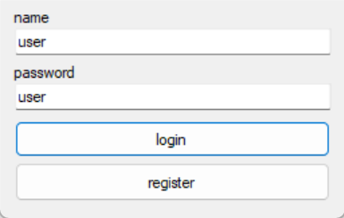
Рисунок 1.1 – Форма логін

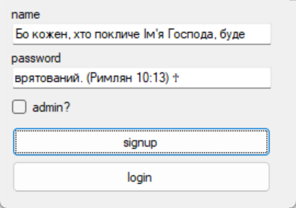
Рисунок 1.2 – Форма реєстрації

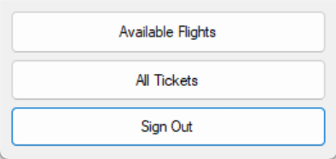
Рисунок 1.3 – Форма меню

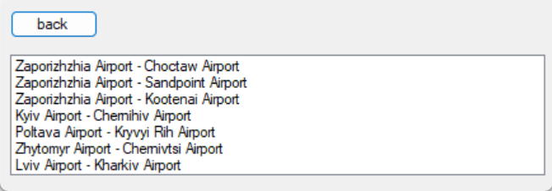
Рисунок 1.4 – Форма перельотів

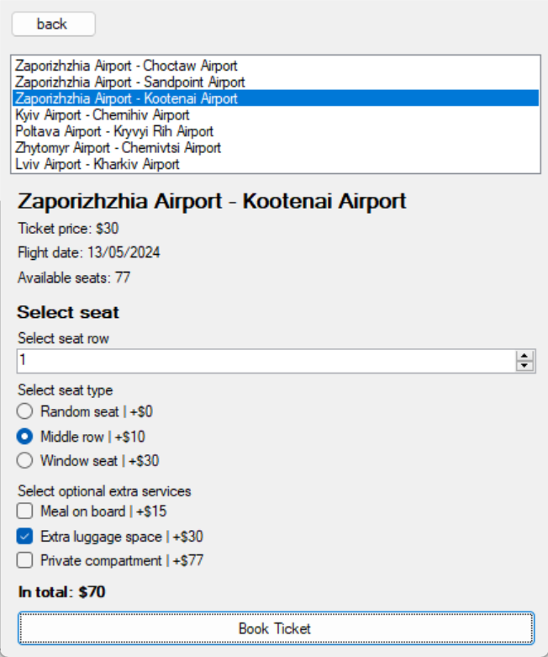
Рисунок 1.5 – Форма перельотів

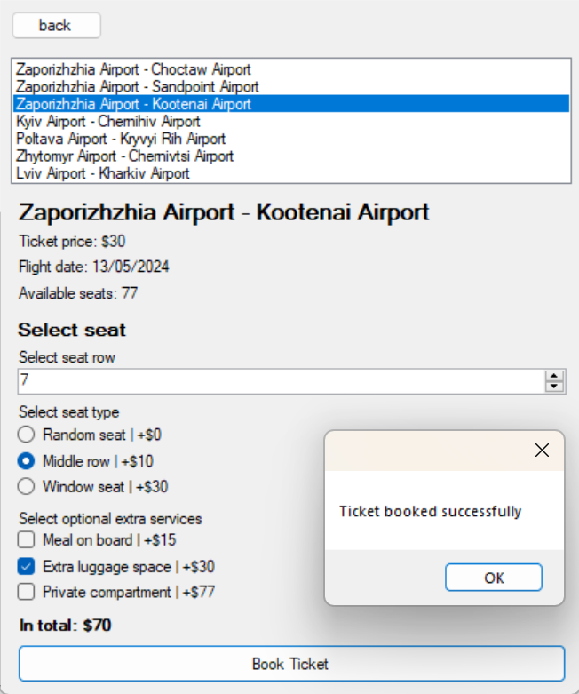
Рисунок 1.6 – Форма перельотів

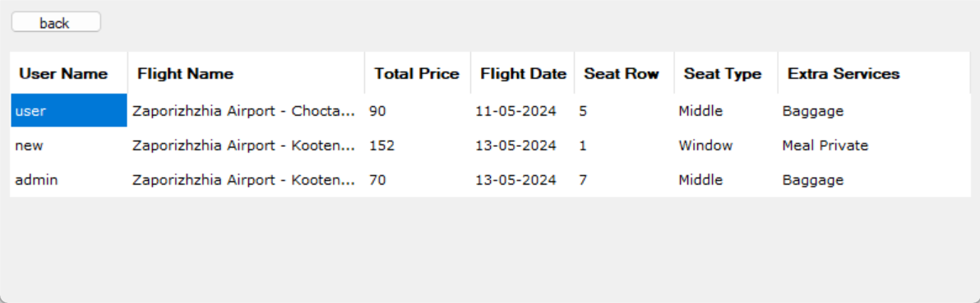
Рисунок 1.7 – Форма квитків

Висновки

Таким чином, ми ознайомилися з принципами компонетно-орієнтованого програмування; а також навчилися застосовувати системний підхід для побудови програмного забезпечення

Контрольні питання

Що таке компонент?

Компонент - це частина, яка поєднується з іншими частинами, утворюючи щось більше. У контексті програмного забезпечення компонент - це програмний пакет, веб-сервіс, веб-ресурс або модуль, який інкапсулює набір пов'язаних функцій або даних.

З чого складається архітектура програмного забезпечення, розробленого на основі компонентів?

Архітектура компонентного програмного забезпечення - це фреймворк для побудови програмного забезпечення на основі багаторазово використовуваних частин. Кожен компонент містить чітко визначену функціональність у вигляді двійкової одиниці, яка зберігається в бібліотеці, а потім додається до програми без зміни інших компонентів.

Які технології розроблення компонентного програмного забезпечення існують?

Компонентно-орієнтована розробка (CBD) - це набір технологій, інструментів і методів, які дозволяють організаціям, що займаються розробкою додатків, пройти весь процес розробки додатків (тобто аналіз, проектування, конструювання і збірку) або будь-який окремий етап за допомогою попередньо визначених компонентно-орієнтованих технологій (таких як патерни розробки додатків, фреймворки, шаблони проектування), інструментів і будівельних блоків додатків.

